Power BI Licensing Comparison
This document provides an in-depth analysis of the types of Power BI licenses, their differences, and the benefits of Power BI Premium over Power BI Pro. It includes screenshots and relevant information from the official Power BI website.

Types of Power BI Licensing
1. Power BI Free
Description: This is the basic version of Power BI for individuals. It allows users to create and view reports and dashboards locally.
Target Audience: Suitable for personal use or small projects.
Features:
- Access to Power BI Desktop.
- Limited data capacity (1 GB per dataset).
- No sharing or collaboration features.
- No access to Power BI service for publishing reports or sharing with others.
2. Power BI Pro
Description: Designed for individual users who need to create, share, and collaborate on reports and dashboards.
Target Audience: Small to medium businesses or teams.
Features:
- All features of Power BI Free.
- Ability to share and collaborate with other Pro users.
- Integration with Office 365 and Azure AD.
- 10 GB per user data storage limit.
3. Power BI Premium
Description: Provides enterprise-grade capabilities with greater data capacity, performance, and scalability.
Target Audience: Large enterprises.
Features:
- All features of Power BI Pro.
- Dedicated cloud resources for faster performance.
- Up to 100 TB of storage.
- Ability to distribute content to free users within the organization.
4. Power BI Premium Per User (PPU)
Description: Offers the benefits of Power BI Premium to individual users at a lower cost.
Target Audience: Smaller organizations or users who require Premium features without needing full capacity.
Features:
- All features of Power BI Pro.
- Access to advanced AI features and larger datasets. 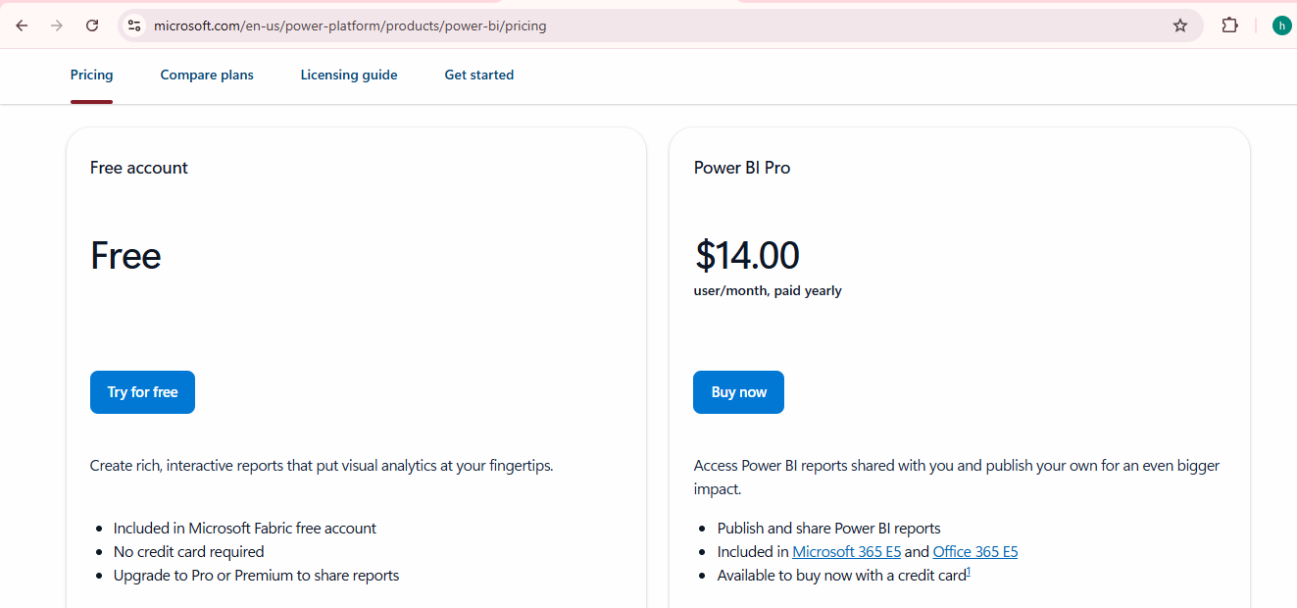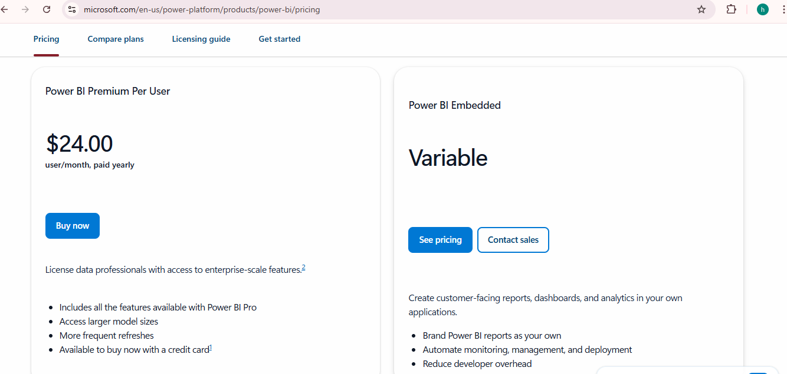

Difference Between All Types of Licensing
Feature | Power BI Free | Power BI Pro | Power BI Premium | Power BI Premium Per User
Data Storage Limit | 1 GB per dataset | 10 GB per user | 100 TB | 100 TB
Sharing & Collaboration | No | Yes, with Pro users | Yes, with both Pro & free users | Yes, with both Pro & free users
Data Refresh | Daily refresh | Up to 8 times/day | Up to 48 times/day | Up to 48 times/day
AI & Advanced Analytics | No | No | Yes | Yes
Report Server | No | No | Yes | No
Maximum Dataset Size | 1 GB | 10 GB | Up to 400 GB | Up to 400 GB

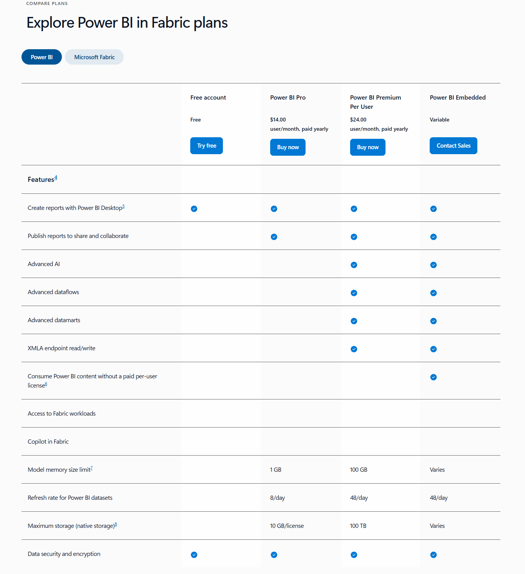

Benefits of Power BI Premium Over Power BI Pro
1. Larger Datasets and Better Performance
Power BI Premium supports datasets up to 400 GB, significantly higher than the 1 GB limit in Power BI Pro. Premium users get faster report generation times due to dedicated cloud resources.
2. More Storage
Premium offers up to 100 TB of storage compared to just 10 GB for Pro.
3. Sharing with Free Users
Premium allows sharing content with users who do not have Power BI Pro licenses.
4. Advanced AI and Analytics
Premium includes advanced AI-powered analytics, machine learning models, and dataflow transformations.
5. Enhanced Data Refresh
Premium allows up to 48 data refreshes per day, while Pro supports only 8.
6. Power BI Report Server
Premium includes Power BI Report Server, allowing on-premises report hosting.
7. Dedicated Cloud Resources
Premium provides dedicated cloud resources, enhancing performance and scalability.
8. Paginated Reports
Premium enables paginated reports for pixel-perfect, printable reports.
9. Power BI for Embedded Analytics
Premium includes Power BI Embedded for integrating reports and dashboards into applications.

